**Docker installation on Windows ( OS Version < 8 )**

1. Download Docker Tool box <https://docs.docker.com/toolbox/toolbox_install_windows/>

2. You will get a DockerToolbox.exe [Size around 200 MB]

3. Install the same with default properties

4. Two shortcuts to desktop

a. Docker Quickstart Terminal

b. Kitematic (Alpha)

5. Double click on and the it will try to download boot2docker (if it is not already available) to

C:\Users\<<username>\.docker\machine\cache\boot2docker.iso from https://github.com/boot2docker/boot2docker/releases /v18.06.1-ce

boot2docker.iso size is around 50 MB.

Docker can’t run on windows. So this script will automatically download, install and create a oracle virtual box. And then it will install docker in it. While downloading , we might need to provide access to oracle.

Note: It will take some time

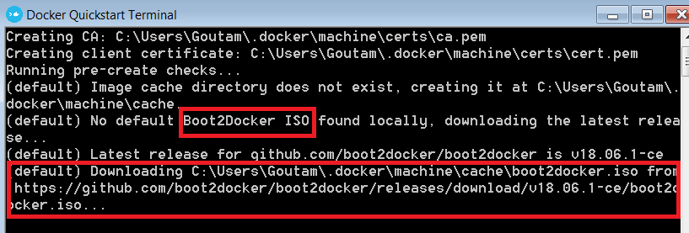

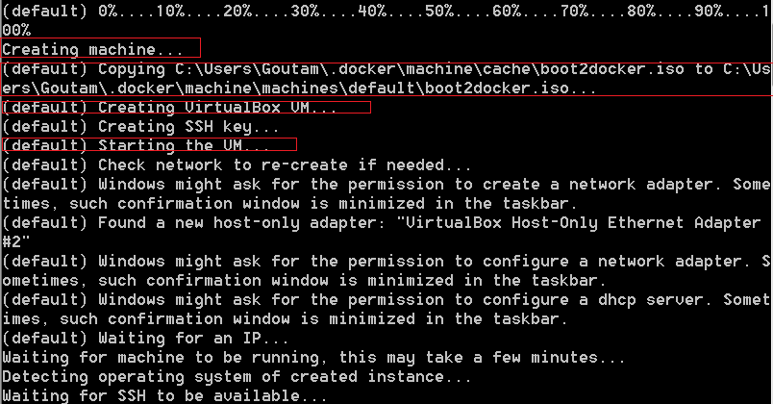

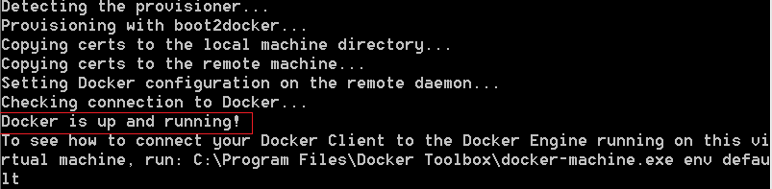

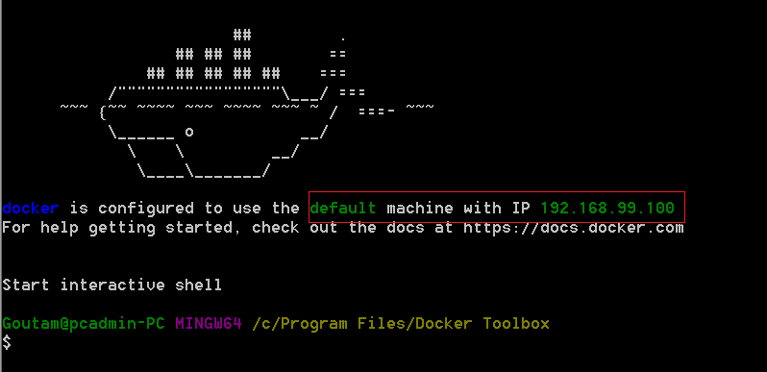

6. Test the ISO inastallation location : C:\Users\<username>\.docker\machine\machines\default and it will looks like this

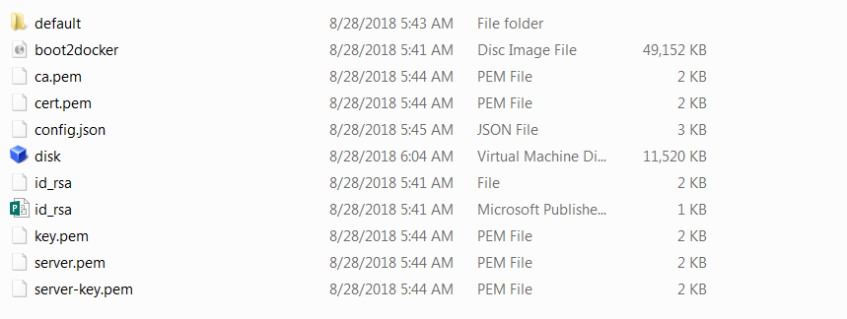

7. Test the connection using ping 192.168.99.100.[Virtual box IP – check above screen shot] It is internal to your PC so nobody can access the VM from outside network

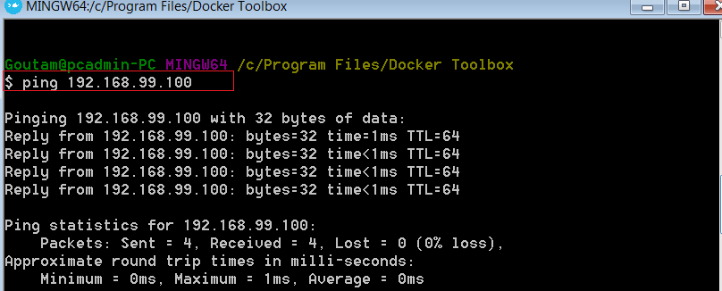

8. docker run hello-world. Basically, it is for testing. It will download “hello-world” image (first time) and execute the image , as a result it will print some statement.

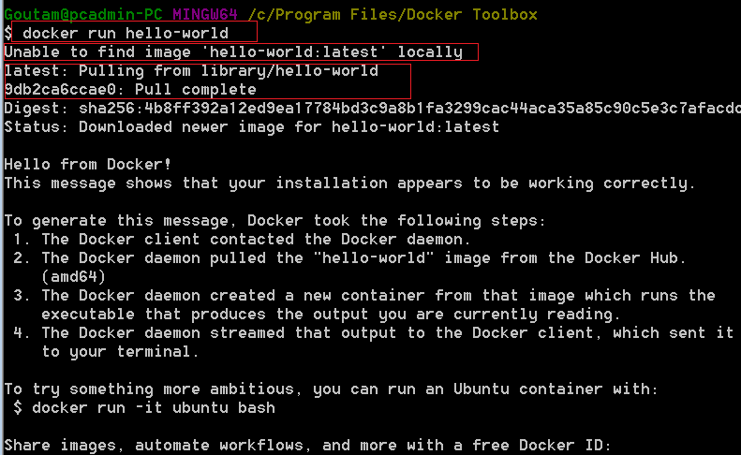

9. docker ps -a to check all running containers.

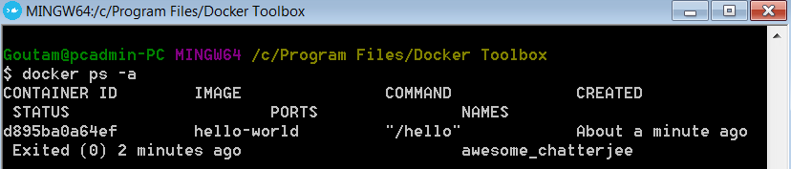

We can kill the container anytime. Using 🡪 docker kill <container ID>

10. “Running a website in a container” testing 🡪 docker run -d **-P** seqvence /static-site

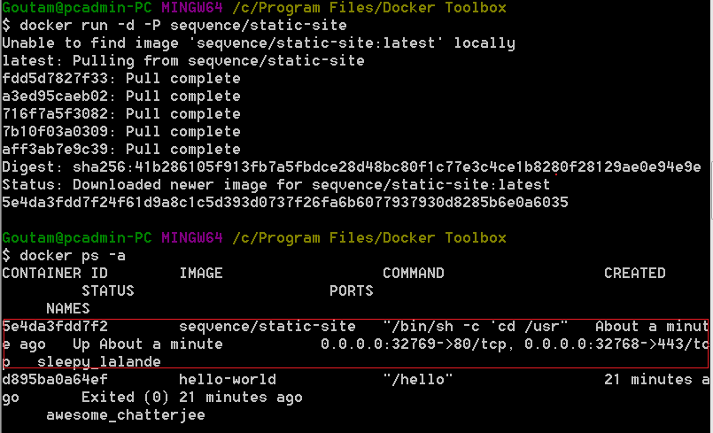

Now a static site is running on 80 port and it is exposed to 32768.

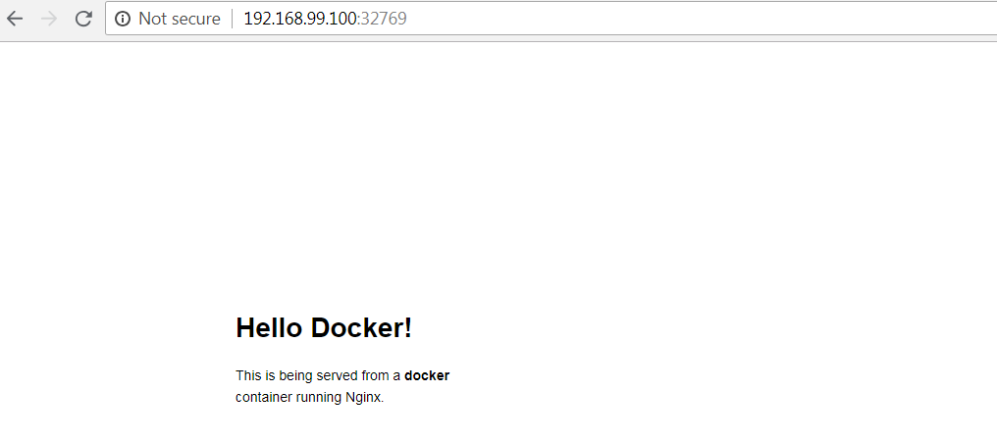

11. **The docker machine that ships with Docker Toolbox comes with only 2GB of RAM, which is not enough for Kafka Connect Cluster.**You need to increase it to at least 4GB by running the following commands:

1. docker-machine stop
2. docker-machine rm default
3. docker-machine create -d virtualbox --virtualbox-memory=6096 --virtualbox-cpu-count=2 default
4. docker-machine start

===========================The End =================================================

Ref: <https://www.ibm.com/developerworks/community/blogs/jfp/entry/Using_Docker_Machine_On_Windows?lang=en>

**Docker installation on Windows ( OS Version >=8 )**

<https://docs.docker.com/docker-for-windows/install/>

In

https://docs.docker.com/docker-for-windows/